**Help Desk – Email version**

The client will login to his account and will find the option of help desk on the right side of his account as shown in the picture below:

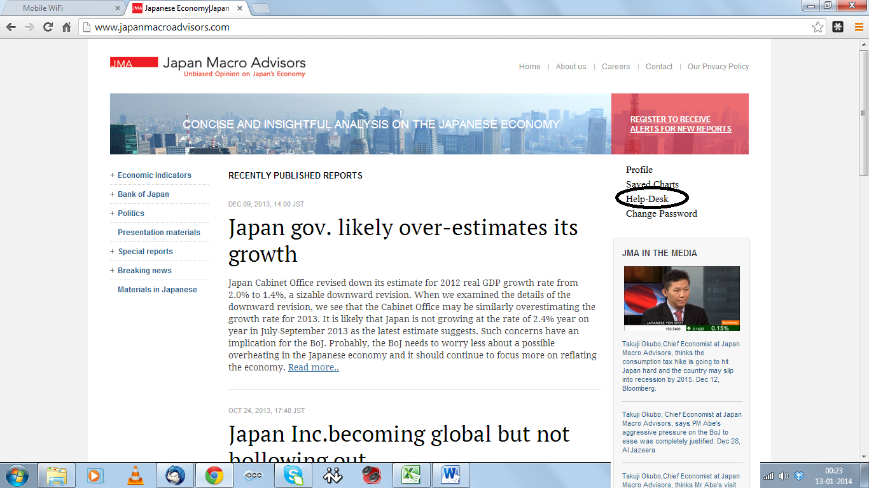

Once client clicks on this tab, small screen pops up with the message box and the text above it as “One of our research-associate will get back to you within one hour, please leave your query below in the description box and hit submit tab at the bottom. We work Mon-Fri: 8:00am - 9:00pm JST hours.”

There will be an option for client to send attachment as well on the same page through “Add attachment” tab above message box.

Once client sends this message by clicking send option at the bottom of popped up screen, we will receive the same as email at [support@japanmacroadvisors.com](mailto:support@japanmacroadvisors.com). Since the client has already logged in so the email that we receive has clients name automatically, as it is fetching data from his logged-in account. And as soon as client sends this email they will receive an acknowledgement email as below (If sent by client after 8:00am and before 9:00pm, Mon-Fri):

Hi Mr. FirstName LastName,

Thank you for sending your query. This is an automated response confirming that your query has been successfully received. To send further updates on this query, please reply to this email. Someone from our team will get back to you within next one hour.

Thanks,   
Support   
Japan Macro Advisors

-------------------------------------------------------------------------------------------------------

And if the client sends an email before 8:00am and after 9:00pm or on Sat-Sun then they will receive the following email as acknowledgement:

Hi Mr. FirstName LastName,

Thank you for sending your query. We operate Mon-Fri: from 8:00am to 9:00pm JST. We will get back to you during our working hours. To send further updates on this query, please reply to this email.

Thanks,   
Support   
Japan Macro Advisors

We will monitor this email address [support@japanmacroadvisors.com](mailto:support@japanmacroadvisors.com) and we also want that [mytasker@japanmacroadvisors.com](mailto:mytasker@japanmacroadvisors.com) receives the same email when something is sent to [support@japanmacroadvisors.com](mailto:support@japanmacroadvisors.com). However, we will always reply through [support@japanmacroadvisors.com](mailto:support@japanmacroadvisors.com) and client is receiving emails to his or her registered email address.